FinFinance Pvt LTD

1. **Business Requirement**

**Platform**

FinFinace is planning to build a platform that facilitates loan transactions between company and customer. All loan applications are approved and sanctioned by the managers. All details are clearly stated upfront during the Loan application.

Users can apply for Personal Loans up to ₹ 3 Lakhs as per the requirement. The documentation needed is minimal and the entire process starting from registration to disbursement takes an average of 30 minutes. The application process is completely online and on approval, the funds are immediately transferred to the wallet account of the applicant.

**KYC**

Customer should be able to register themselves and request for loan.

**Loan Recovery**

There should be facility to enable the agent who are working in call centers to recover the loan and update the loan details.

**Reporting**

Platform should be able to generate the daily , weekly and monthly automated reports, A separate data warehouse should be build for the reporting and visualization

1. **Proposed Solution**

* **Website/Portal**

Below are the user interface for the customer and agent

**Home Page**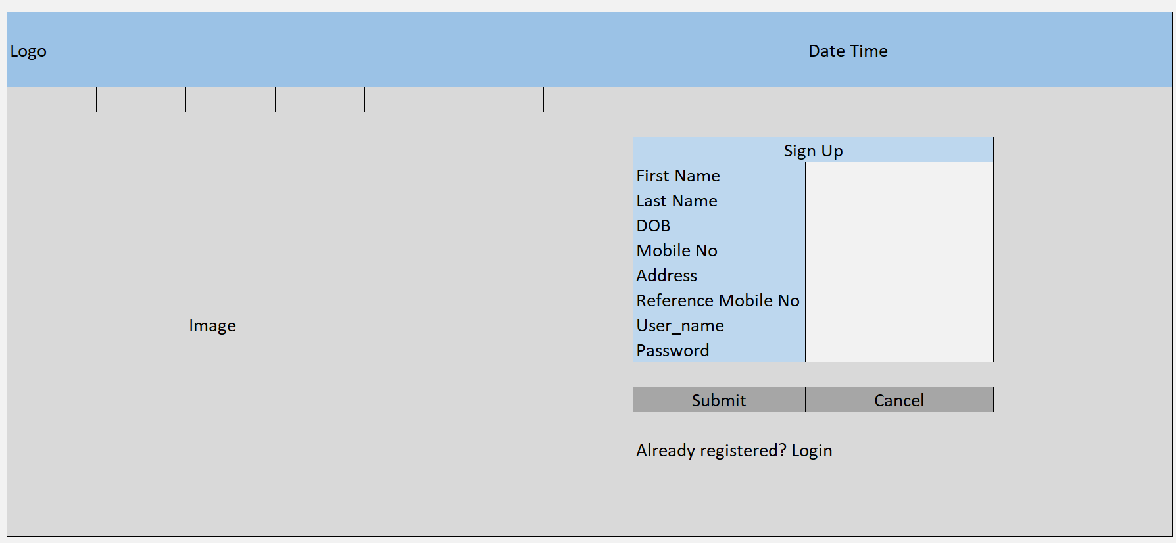

**Login Page**

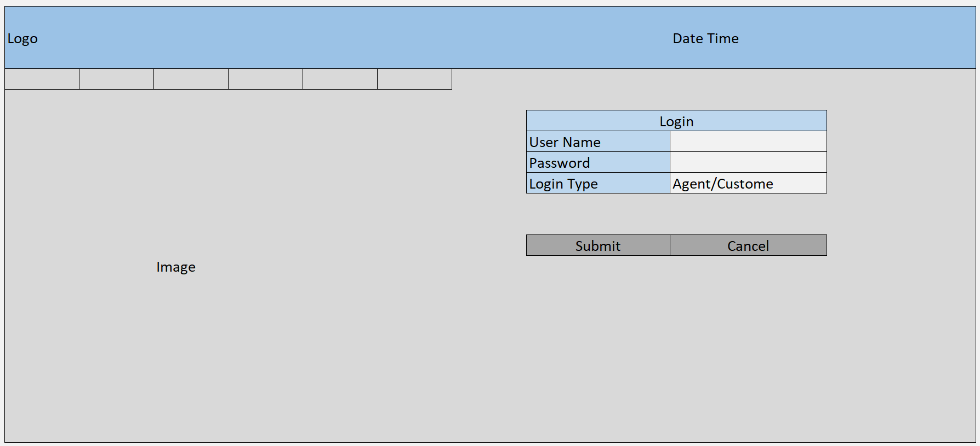

**Loan Request**

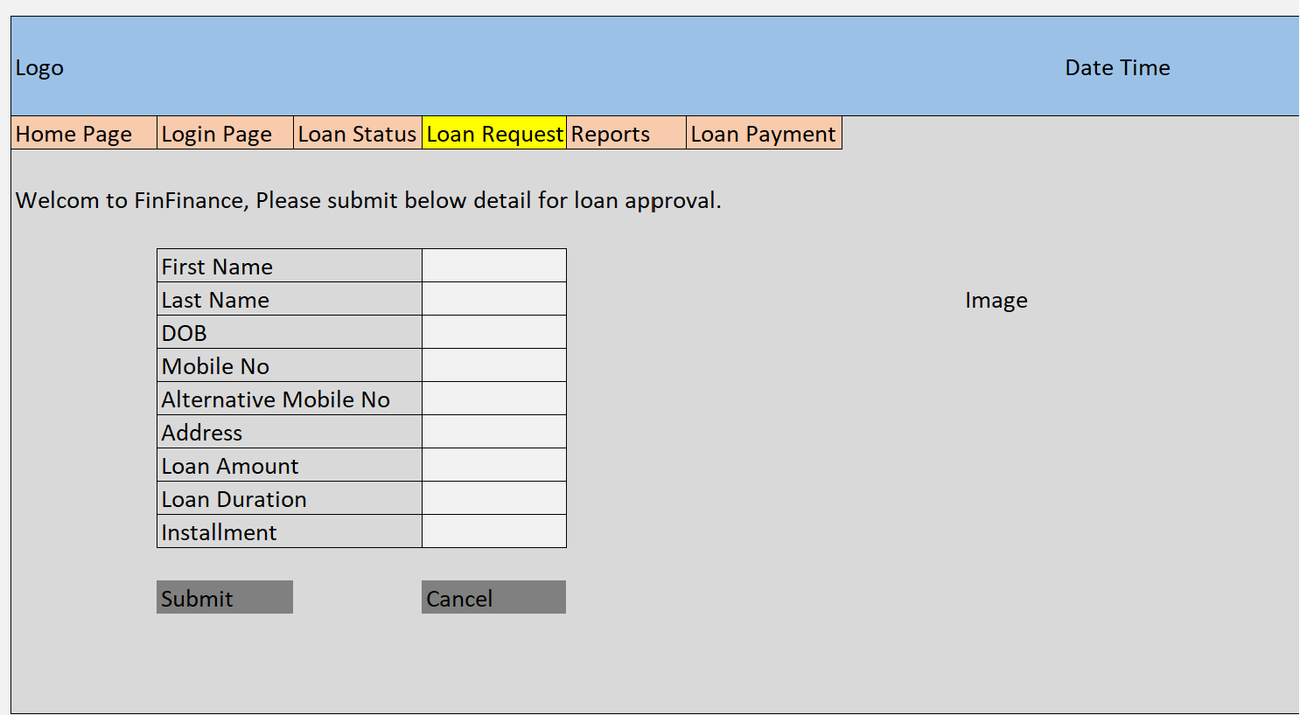

**Loan Payment**

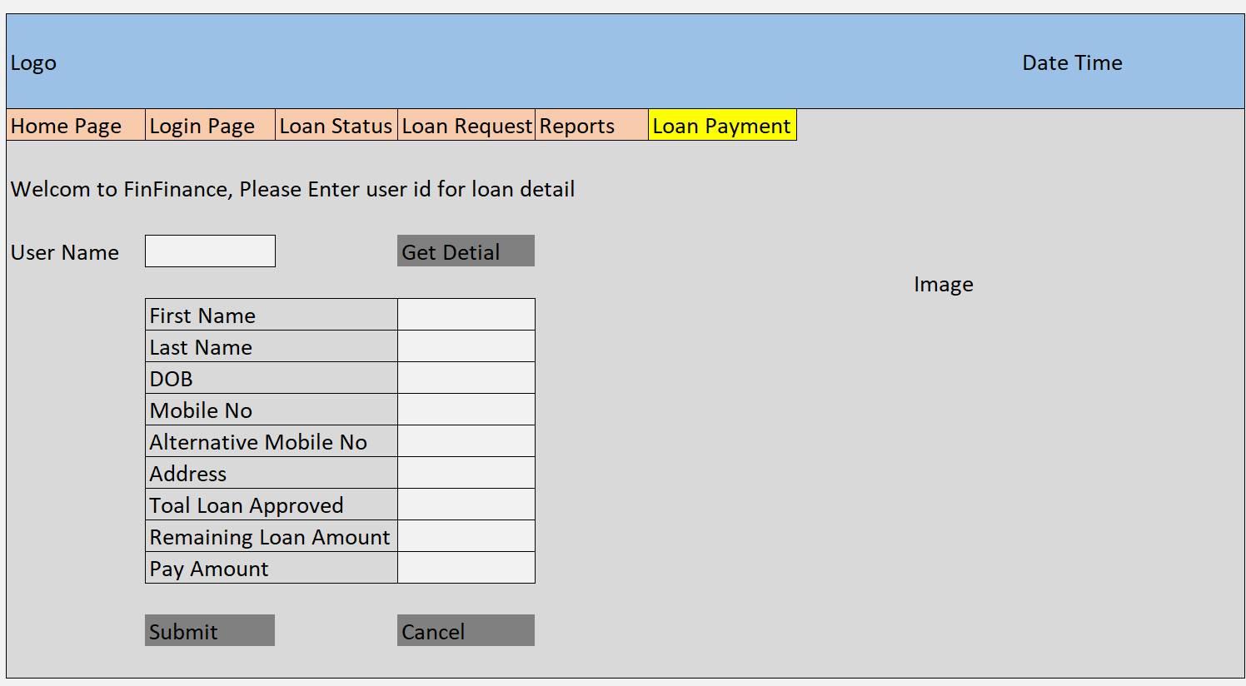

**Agent Loan Recovery**

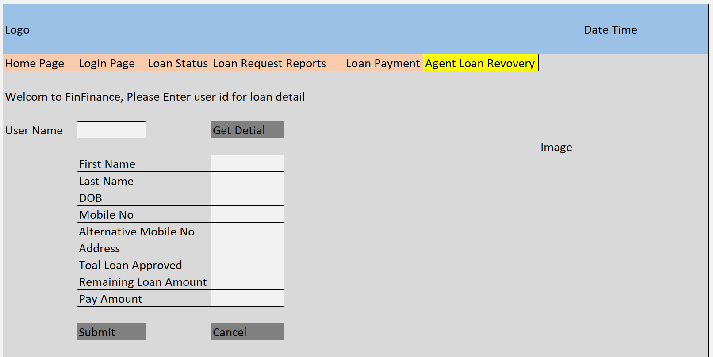

**Technology Stack**

* + Java
  + HTML, CSS, Java Script
  + My SQL
  + Power BI